**#Program to have Spotlight Effect on image:**

**import numpy as np**

**import matplotlib.pyplot as plt**

# Load the image

**pic = plt.imread("parrot.jpg")** # Ensure the correct path to the image

**dk = pic.copy()** # Create a copy of the image for modification

# Step 1: Get the dimensions of the image

**height, width, _ = dk.shape**

# Step 2: Define the circle (spotlight) center and radius

**circle_center = (width / 2, height / 2)**

**circle_radius = min(width, height) / 2**

# Step 3: Create a meshgrid for pixel coordinates

**x = np.arange(width)**

**y = np.arange(height)**

**xx, yy = np.meshgrid(x, y)**

# Step 4: Calculate the distance of each pixel from the circle's center

**distance_from_center = np.sqrt((xx - circle_center[0])**2 + (yy - circle_center[1])**2)**

# Step 5: Determine pixels outside the circle and adjust their intensity

**outside_circle = distance_from_center > circle_radius**

**scaling_factor = distance_from_center[outside_circle] / circle_radius**

# Modify pixel values for points outside the circle

**dk[outside_circle] = (dk[outside_circle] / scaling_factor[:, None])**

# Clip values to ensure valid image range

**if dk.max() > 1: # Image in 0-255 range**

**dk = np.clip(dk, 0, 255).astype(np.uint8)**

**else: # Image in 0-1 range**

**dk = np.clip(dk, 0, 1)**

# Step 6: Display the original and modified images

**plt.figure(figsize=(10, 5))**

# Original image

**plt.subplot(1, 2, 1)**

**plt.title("Original Image")**

**plt.imshow(pic)**

**plt.axis("off")**

# Spotlight effect image

**plt.subplot(1, 2, 2)**

**plt.title("Spotlight Effect")**

**plt.imshow(dk)**

**plt.axis("off")**

**plt.tight_layout()**

**plt.show()**

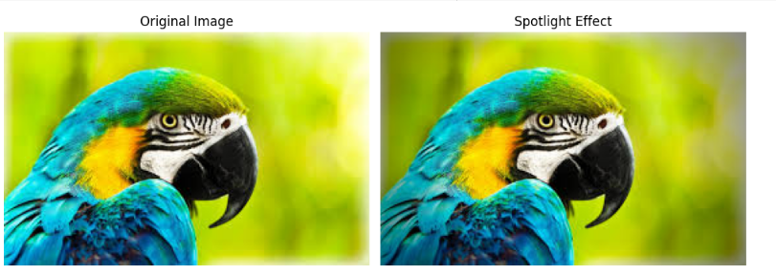

**#Program to Create a visualization to represent points inside a circular region on a rectangular grid.**

